**Business Directory Web Site**

portal for customer to enter their business information via website. The site should be similar to with bootstrap: [http://www.sitediscount.ru/videoStrap_v1.0.1._pre-styled_app_v.1.0/index.html#](http://www.sitediscount.ru/videoStrap_v1.0.1._pre-styled_app_v.1.0/index.html)

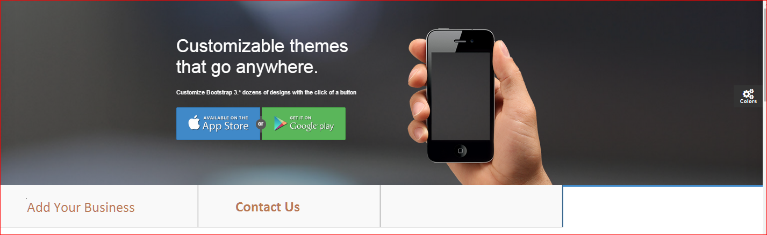

Vendor or anyone should be able to add A Business. There is no login required for anyone to add business information. Once some add a Business via the portal (Add Your Business); Admin should get an email notification that Vendor has been added with Admin Login Link and Vendor Name. Admin will login into the portal via Admin Login and review and approve the Listing to show on a mobile.

1. **Vendor Requirement Add: ( Other than option fields are must be entered)**
   1. Vendor Name:
   2. Phone Number:
      * Office # :
      * Cell # :
   3. Street Address
   4. City
   5. Province
   6. Postal Code
   7. Country
   8. Category – **Note: Predefined Category by Admin.**
   9. Open Hours should be this Format

**Hours:**

|  |  |
| --- | --- |
| Monday | 11:00 am – 2:00 am |
| Tuesday | 11:00 am – 2:00 am |
| Wednesday | 11:00 am – 2:00 am |
| **Thursday** | **11:00 am – 2:00 am** |
| Friday | 11:00 am – 2:00 am |
| Saturday | 3:00 pm – 2:00 am |
| Sunday | 3:00 pm – 2:00 am |

* 1. Allow Vendor upload (1-3) Images. (optional)
     + 1. If there is no image uploaded then set a default one image as Vendor image.
  2. Email Address (optional)
  3. Web Site Link (optional)
  4. Social Media Link: ( Optional) – Allow user to enter link for each social media
* Facebook
* Twitter
* YouTube
* Instagram

1. **Events Requirement Add: ( Other than option fields are must be entered)**
   1. Event Name
   2. Event Date:
   3. Stat time & End Time:
   4. Even Taking Place : Address

* Street Address
* City
* Province
* Postal Code
* Country
  1. Contact Number:
     + Office # :
     + Cell # :
  2. Event Type : Free or Paid
     + If it paid: Field for Dollar Amount
  3. Email Address (optional)
  4. Web Site Link (optional)
  5. Social Media Link: ( Optional) – Allow user to enter link for each social media
* Facebook
* Twitter
* YouTube
* Instagram

1. **Admin Requirement :( Other than option fields are must be entered):**
   1. Admin will Following Tab:
      * Approved Vendor
      * Pending Approval
      * Vendor Deals
      * Promo Vendors.
   2. **Approved Vendor:**
      * List all the Vendor Name with (Active or Deactivate) Status.
      * When I click on the Vendor name; the page should be in view mode with vendor information and should have an Edit button for Admin to edit the details.
      * Admin should be able to set the Status to (Active or Deactivate).
   3. **Pending Approval**
      * List the entire Vendors that are pending for Approval with a button (Approve or Reject).
      * When I click on the Vendor name; the page should be in view mode with vendor information and should have an Edit button for Admin to edit the details.
   4. **Vendor Deals**
      * Allow the Vendor Search for Vendor or Select a Vendor; once Admin select a Vendor; allow the Admin to **Add multiply** Deals for selected Vendor.
        1. Deals Information:

* Deals Name :
* Deals Expire Date ( Stat and End Date) – Have a Calendar to select the dates
* Allow ( 1 – 3) Images upload
* Description for Deals.
  + - Admin should have full control to remove, Add , Edit Deals for any Vendor
  1. **Promo Vendor** 
     + Vendor Name
     + Promotion Period: - ( Stat and End Date) – Have a Calendar to select the dates
     + This Will Allow to Search for Vendor And Add Images (1- 3) per Vendor.
  2. **Category** **For Vendor** 
     + **Category** – Predefined Category by Admin and Admin should be able to Edit or Add new Category

1. Automotive
   1. Automobile Dealers, Sales & Lease
   2. Automobile Maint. & Repairs
   3. Automobile Parts & Supplies
   4. Automobile Rentals
   5. Automobile Towing
   6. Automobile Windshield
2. Computers & Internet
   1. Computer Sales & Training
   2. E-Commerce
   3. Internet Services
3. Education & Training
   1. Books & Publications
   2. Education
   3. Fine Arts
   4. Scholarship Funds
4. Entertainment
   1. Cinemas
   2. Music
5. Food & Dining
   1. Bakery
   2. Catering & Take-out
   3. Restaurant Supplies
   4. Restaurants
6. Health & Medicine
   1. Acupuncture
   2. Dentists
   3. Doctors
   4. Health Services
   5. Home Care
   6. Optometrist
   7. Pharmacies
   8. Physicians & Health Services
   9. Physiotherapy
   10. Rehap Clinics
   11. Water
7. Home Services
   1. Air Cond., Heating & Refrigeration
   2. Alarms
   3. Carpet & General Clearners
   4. Duct Cleaners
   5. Flooring
   6. Interior Decorators
   7. Home Inspection
   8. Kitchen Cabinets
   9. Kitchen Counter Tops
   10. Lock Smith
   11. Painting
   12. Plumbing Services
   13. Pest Control
   14. Roofing
   15. Vacuum Sales
   16. Water
   17. Woodwork Specialists
8. Legal & Financial
   1. Accounting & Tax Consulting
   2. Accident Injuries
   3. Bankruptcy
   4. Banks
   5. Loans
   6. Credit, Collection & Counselling Services
   7. Financial Consultants
   8. Insurance Agents & Brokers
   9. Insurance Claims/Accident Benefits
   10. Investment Consultants
   11. Barristers & Solicitors
   12. Legal Reps/Immigration Consultants
   13. Money Transfer
   14. Mortgage & Financial Services
9. Media
   1. Advertising
   2. Newspapers & Magazines
   3. Radio Programs
   4. Television Programs
   5. Tamil Services
10. Personnel Services
    1. Day Care
    2. Tailors
11. Professional Services
    1. Architectural & Engineering Services
    2. Builders
    3. Building Inspection
    4. Carpentry
    5. Cellular
    6. Cleaning & Janitorial
    7. Doors & Windows
    8. Drapes, Window Blinds & Shutters
    9. Driving Schools
    10. Dry Cleaners
    11. Electrical & Appliances Services
    12. Electronics, TV, VCR Sales & Repairs
    13. Fire Inspection
    14. Funeral Services
    15. Heating
    16. Home Renovations
    17. Land Surveying
    18. Landscaping Services
    19. Movers
    20. Picture Framing
    21. Plumbing Services
    22. Printers & Graphic Consultants
    23. Marriage Registrar
    24. Resume Services
    25. Screen Printing
    26. Signs
    27. Telecommunications
    28. Traffic Ticket Consultants
    29. Translation service
    30. Trophies & Awards
    31. Video Rentals
    32. Web Design
    33. Welders
12. Real Estate
    1. Apartment & House Rentals
    2. Real Estate Consultants
    3. Real estate Agents & Brokers
13. Religion
    1. Churches
    2. Priests
    3. Temple Products
    4. Temples
14. Retail & Whole Sale
    1. Arts & Crafts
    2. Audio, Video & Gifts
    3. Book Distributors
    4. Carpet Sales
    5. Furniture Sales
    6. Glass & Mirror
    7. Groceries
    8. Import/Export
    9. Kitchen Appliances
    10. Opticians
    11. Sports & Fashion Wear
    12. Wholesale Distributors
15. Travel & Transport
    1. Airlines
    2. Bus Services
    3. Courier Services
    4. Hotel & Motels
    5. Shipping Agents
    6. Transport
    7. Travel Agents
16. Wedding & Parties
    1. Astrological Services & Marriage Consultants
    2. Banquet Halls
    3. Bridal Ornamentation & Beauty Care
    4. Cake Making & Decorations
    5. Chair Rentals
    6. DJ Services
    7. Event Planners
    8. Florists & Floral Arrangements
    9. Hair Dressing
    10. Jewellers
    11. Limousine Services
    12. Party Supllies & Rentals
    13. Photography
    14. Priests
    15. Marriage Registrar
    16. Textiles
    17. Video Productions
    18. Wedding Services & Nathaswaram
    19. Wedding, Banquet & Party Halls